|  |  |
| --- | --- |
| Name Of The Student | SAHIL SENGRA |
| Internship Project Topic | WEBPAGE UI DESIGN |
| Name of the Organization | TCS-ION |
| Name of the Industry Mentor | Atul Devrukhka, Anushree_deshpande ( Administrator ) |
| Name of the Institute | PREPINSTA |

|  |  |  |
| --- | --- | --- |
| Date | Day # | Hours Spent |
| 17-01-2023 | 27 | 4.5HR |
| Activities done during the day:   1. Went through the links given in the project reference material, and tried to connect it with the project objective. 2. Making of Home Page & Banner 3. I attached all my project till now. 4. This word file contains logos, framework design, homepage UI Design & Some SubPages UI design. 5. banners of the homepages. 6. Icons Used in Pages. 7. Login design. 8. Making of workframe for 2nd webpage. 9. Icons for second webpage. 10. Start Designing For Second webpage. 11. Insert all icons and banners 12. Frame Work for 3rd webpage 13. Icon and content writing for 3rd web page. 14. Icon and content writing for 3rd web page. 15. Implement all the process in adobe XD. 16. Make Protocall for website 1. 17. Make protocall for website 2.   Please Evaluate my project.. if any error is come please tells me.  My assignment is given below.  The order is bottom to top:) | | |

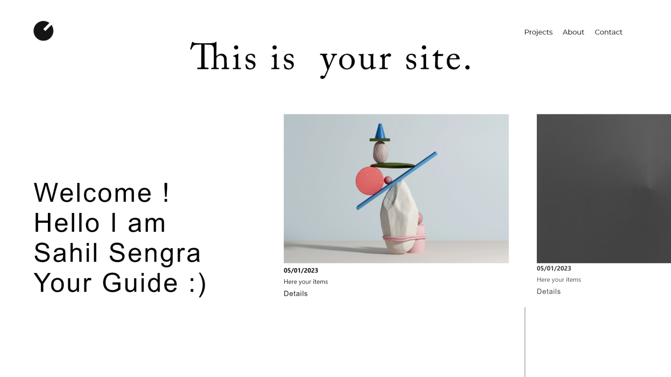

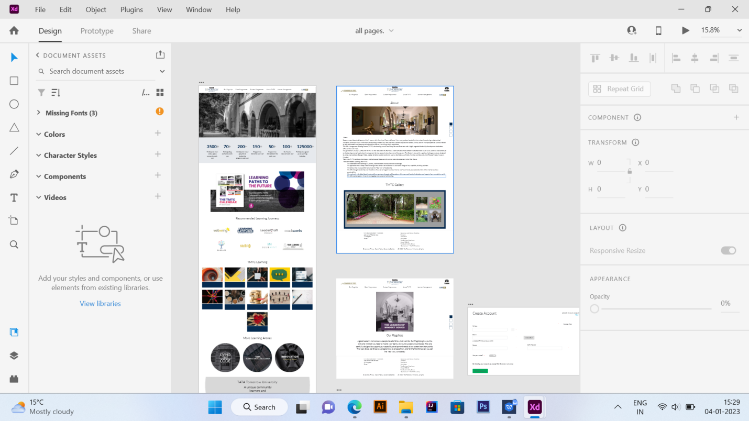

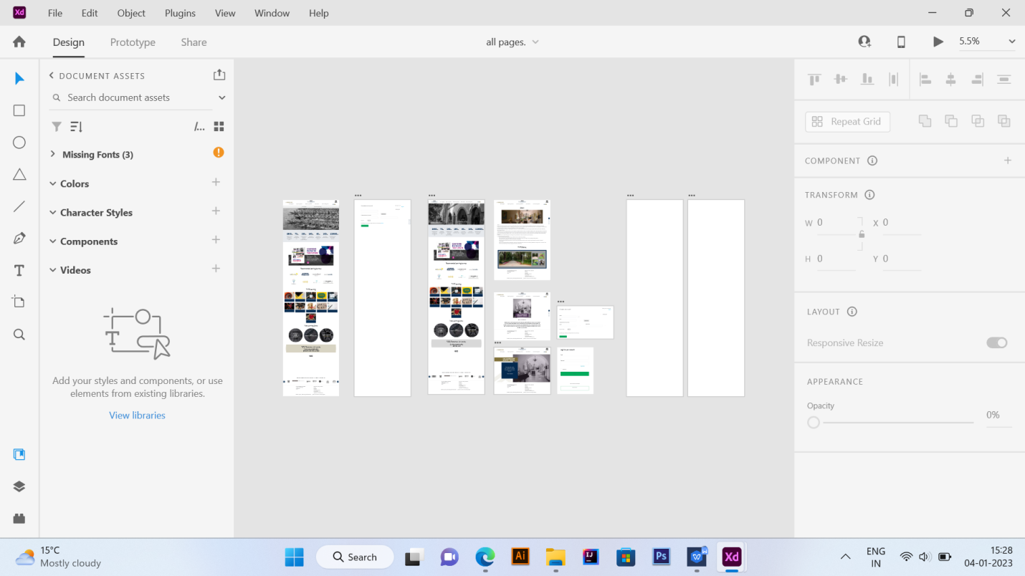

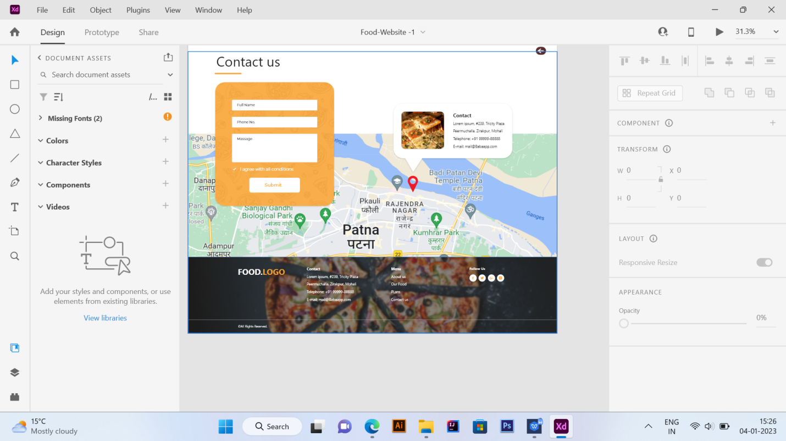

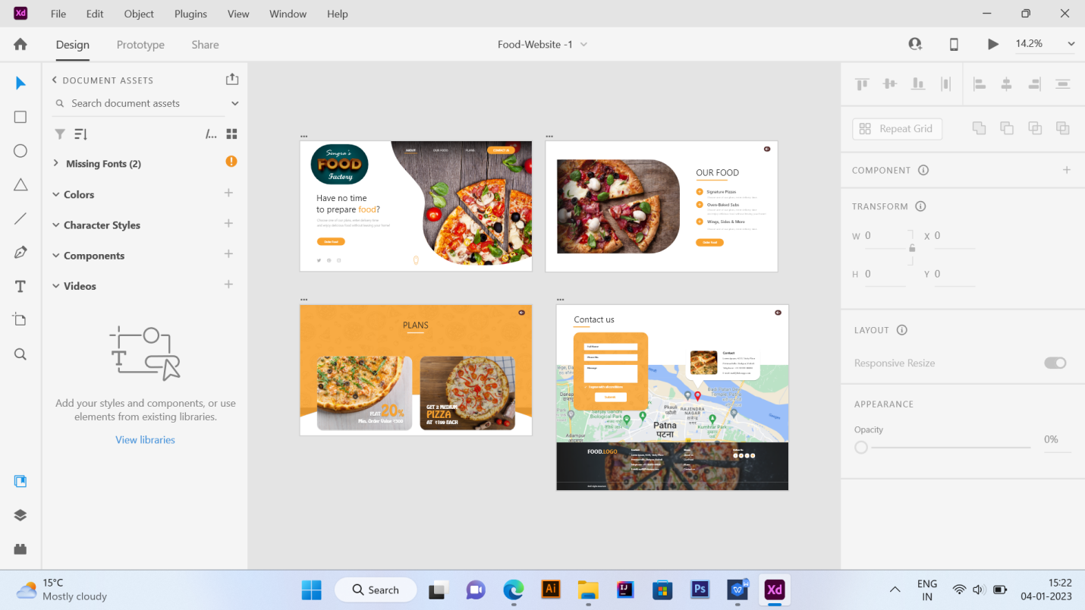

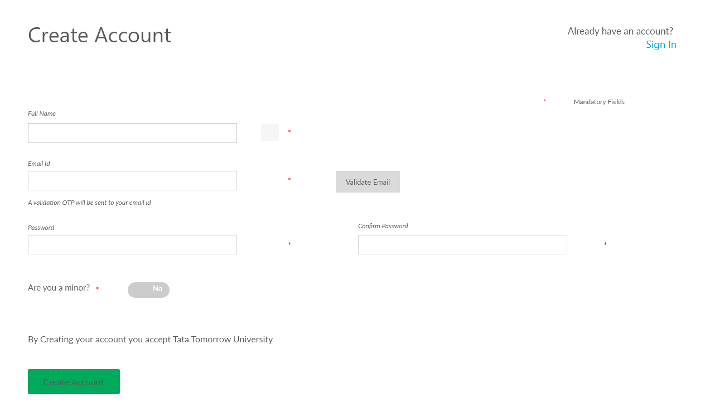

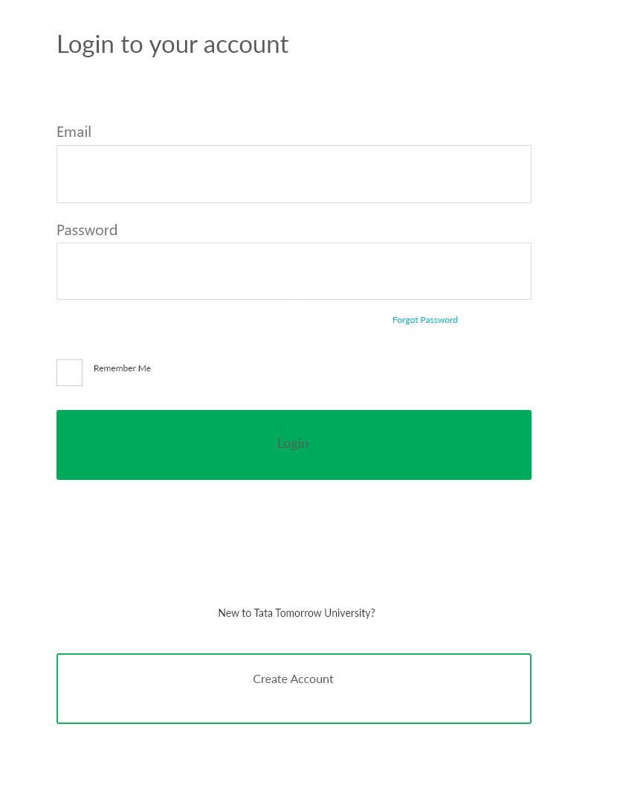

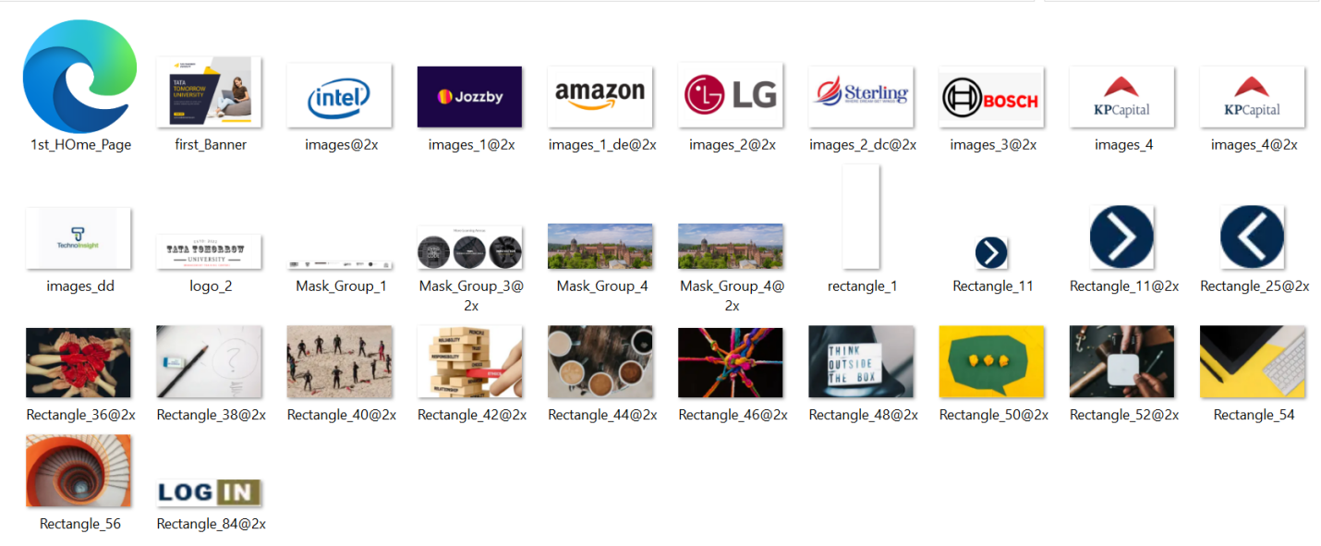





Page & Subpages

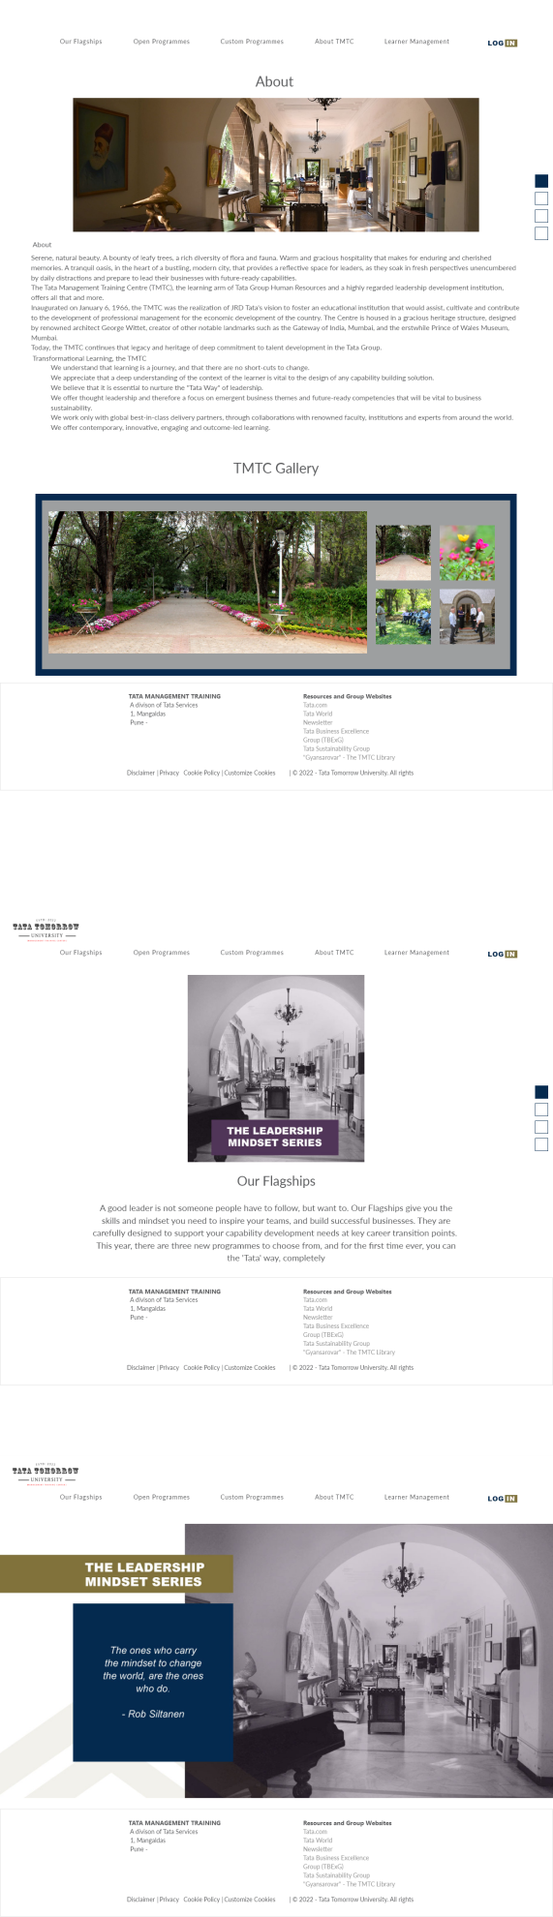



CLICK THIS ICON : THIS IS THE LOGO  
  
 

HERE THE PNG FILE OF MY FRAME WORK

